STUDENT-COUNCIL ELECTION TALLY SYSTEM

ABSTRACT
The student-Council Election Tally System is a Java-based application designed to simplify the process of conducting and managing student council elections. The system allows users to register candidates, record votes, calculate the total votes received by each candidate, and display the final election results. It identifies the winner based on the highest number of votes and handles situations where candidates receive equal votes.
The project demonstrates Java programming concepts from CO1 to CO6, including computational thinking, algorithms, flowcharts, data types, operators, conditional statements, loops, methods, recursion, and arrays. It also incorporates object-oriented programming concepts such as classes, objects, constructors, encapsulation, interfaces, and exception handling. String manipulation, sorting, searching, and file handling are used to manage candidate information and store election results. Furthermore, collections such as ArrayList, HashMap, and HashSet, along with lambda expressions and stream operations, help organize and process election data efficiently.
This project provides a practical understanding of how Java programming concepts can be combined to develop an organized, reliable, and user-friendly election management application.

ADVANTAGES
- Simplifies vote counting: Automatically calculates the total votes received by each candidate.
- Reduces manual errors: Minimizes mistakes associated with manual vote counting and result calculation.
- Organizes candidate information: Stores candidate details and vote counts in a structured manner.
- Identifies election winners: Displays the candidate with the highest number of votes and identifies ties.
- Provides candidate searching: Allows users to search for candidates by name.
- Supports data storage: Saves election results in a text file for future reference.
- Improves data management: Uses Java collections such as ArrayList, HashMap, and HashSet to manage candidate records.
- Demonstrates object-oriented programming: Uses classes, objects, encapsulation, constructors, and interfaces.
- Handles invalid input: Uses validation and exception handling to manage incorrect entries.
- Generates useful reports: Uses sorting and stream operations to summarize election results.
- Supports modular development: Organizes functionality into separate classes and methods, making the program easier to maintain and extend.
- Provides practical learning: Demonstrates the application of Java concepts from CO1 to CO6 in a single project.

CODE
import java.util.*;
import java.io.IOException;
import java.nio.file.*;
import java.util.stream.Collectors;

class Candidate {
private final int id;
private String name;
private int votes;

public Candidate(int id, String name) {
this.id = id;
setName(name);
this.votes = 0;
}

public int getId() {
return id;
}

public String getName() {
return name;
}

public int getVotes() {
return votes;
}

public void setName(String name) {
if (name == null || name.trim().isEmpty()) {
throw new IllegalArgumentException(
"Candidate name cannot be empty."
);
}
this.name = name.trim();
}

public void addVote() {
votes++;
}

public String toString() {
return id + " - " + name + " : " + votes + " votes";
}
}

interface Reportable {
void displayReport();
}

class Election implements Reportable {
private final List<Candidate> candidates = new ArrayList<>();
private final Set<String> candidateNames = new HashSet<>();
private final Map<Integer, Candidate> candidateMap = new HashMap<>();

public void addCandidate(int id, String name) {
String key = name.trim().toLowerCase(Locale.ROOT);

if (candidateNames.contains(key)) {
throw new IllegalArgumentException(
"Duplicate candidate name."
);
}

Candidate candidate = new Candidate(id, name);
candidates.add(candidate);
candidateNames.add(key);
candidateMap.put(id, candidate);
}

public void castVote(int candidateId) {
Candidate candidate = candidateMap.get(candidateId);

if (candidate == null) {
throw new IllegalArgumentException(
"Invalid candidate ID."
);
}

candidate.addVote();
}

public Candidate searchCandidate(String name) {
return candidates.stream()
.filter(c -> c.getName().equalsIgnoreCase(name.trim()))
.findFirst()
.orElse(null);
}

public void displayReport() {
System.out.println("\n===== ELECTION RESULTS =====");

candidates.stream()
.sorted(Comparator.comparingInt(
Candidate::getVotes
).reversed())
.forEach(System.out::println);

if (candidates.isEmpty()) {
System.out.println("No candidates available.");
return;
}

int highestVotes = candidates.stream()
.mapToInt(Candidate::getVotes)
.max()
.orElse(0);

List<Candidate> winners = candidates.stream()
.filter(c -> c.getVotes() == highestVotes)
.collect(Collectors.toList());

if (winners.size() == 1) {
System.out.println("Winner: " + winners.get(0).getName());
} else {
System.out.println("Tie between:");
winners.forEach(c -> System.out.println(c.getName()));
}

System.out.println("Total votes: " +
candidates.stream().mapToInt(
Candidate::getVotes
).sum());

System.out.println("Candidates: " + candidates.size());
}

public void searchByName(String name) {
Candidate result = searchCandidate(name);

if (result == null) {
System.out.println("Candidate not found.");
} else {
System.out.println("Found: " + result);
}
}

public void showCandidates() {
candidates.forEach(System.out::println);
}

public void saveResults() throws IOException {
Path path = Paths.get("election_results.txt");

List<String> lines = new ArrayList<>();
lines.add("STUDENT COUNCIL ELECTION RESULTS");
lines.add("Candidate ID | Name | Votes");

for (Candidate c : candidates) {
lines.add(c.getId() + "|" +
c.getName() + "|" + c.getVotes());
}

Files.write(path, lines);
System.out.println("Results saved to election_results.txt");
}

public void readResults() throws IOException {
Path path = Paths.get("election_results.txt");

if (!Files.exists(path)) {
System.out.println("No saved results found.");
return;
}

System.out.println("\n===== SAVED RESULTS =====");

try (var reader = Files.newBufferedReader(path)) {
String line;

while ((line = reader.readLine()) != null) {
System.out.println(line);
}
}
}

public void showStreamSummary() {
System.out.println("\n===== STREAM SUMMARY =====");

long candidatesWithVotes = candidates.stream()
.filter(c -> c.getVotes() > 0)
.count();

String names = candidates.stream()
.map(Candidate::getName)
.sorted(String.CASE_INSENSITIVE_ORDER)
.collect(Collectors.joining(", "));

System.out.println(
"Candidates with votes: " + candidatesWithVotes
);
System.out.println("Names alphabetically: " + names);
}
}

public class StudentCouncilElection {
public static void main(String[] args) {
Scanner sc = new Scanner(System.in);
Election election = new Election();

try {
System.out.print("Enter number of candidates: ");
int n = Integer.parseInt(sc.nextLine().trim());

if (n <= 0) {
throw new IllegalArgumentException(
"Number of candidates must be positive."
);
}

for (int i = 1; i <= n; i++) {
System.out.print(
"Enter candidate " + i + " name: "
);
String name = sc.nextLine();

election.addCandidate(i, name);
}

boolean running = true;

while (running) {
System.out.println("\n===== ELECTION MENU =====");
System.out.println("1. Display candidates");
System.out.println("2. Cast vote");
System.out.println("3. Display results");
System.out.println("4. Search candidate");
System.out.println("5. Save results");
System.out.println("6. Read saved results");
System.out.println("7. Stream summary");
System.out.println("8. Exit");
System.out.print("Enter choice: ");

int choice = Integer.parseInt(
sc.nextLine().trim()
);

switch (choice) {
case 1:
election.showCandidates();
break;

case 2:
System.out.print("Enter candidate ID: ");
int id = Integer.parseInt(
sc.nextLine().trim()
);

election.castVote(id);
System.out.println("Vote recorded successfully.");
break;

case 3:
election.displayReport();
break;

case 4:
System.out.print("Enter candidate name: ");
election.searchByName(sc.nextLine());
break;

case 5:
election.saveResults();
break;

case 6:
election.readResults();
break;

case 7:
election.showStreamSummary();
break;

case 8:
running = false;
System.out.println("Election system closed.");
break;

default:
System.out.println("Invalid menu choice.");
}
}

} catch (NumberFormatException e) {
System.out.println("Error: Please enter a valid number.");
} catch (IllegalArgumentException e) {
System.out.println("Error: " + e.getMessage());
} catch (IOException e) {
System.out.println("File error: " + e.getMessage());
} finally {
sc.close();
}
}
}

OUTPUT 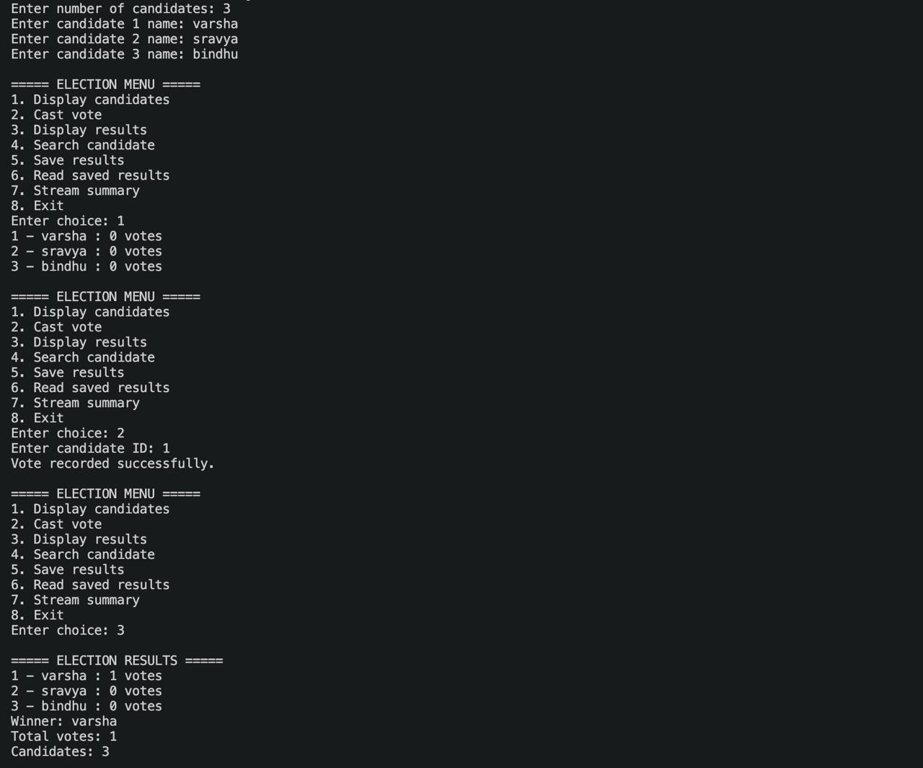 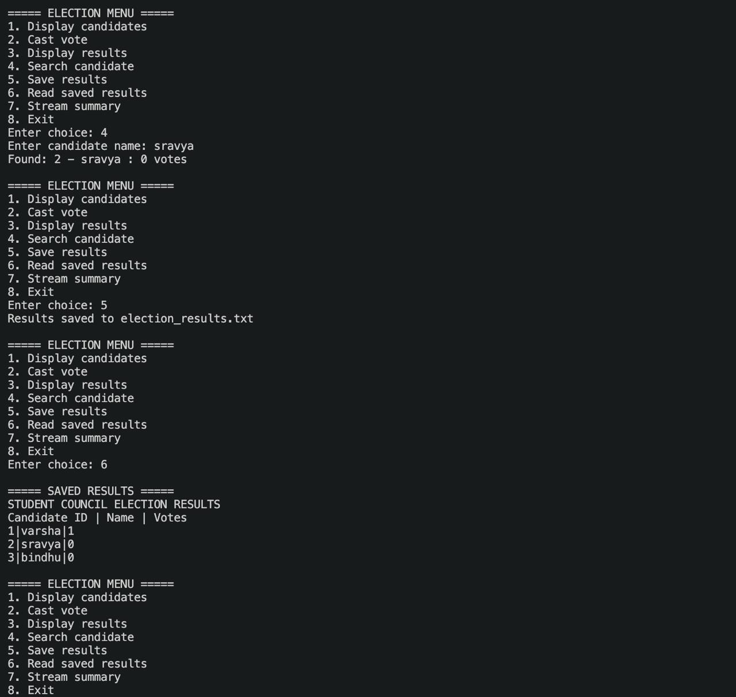

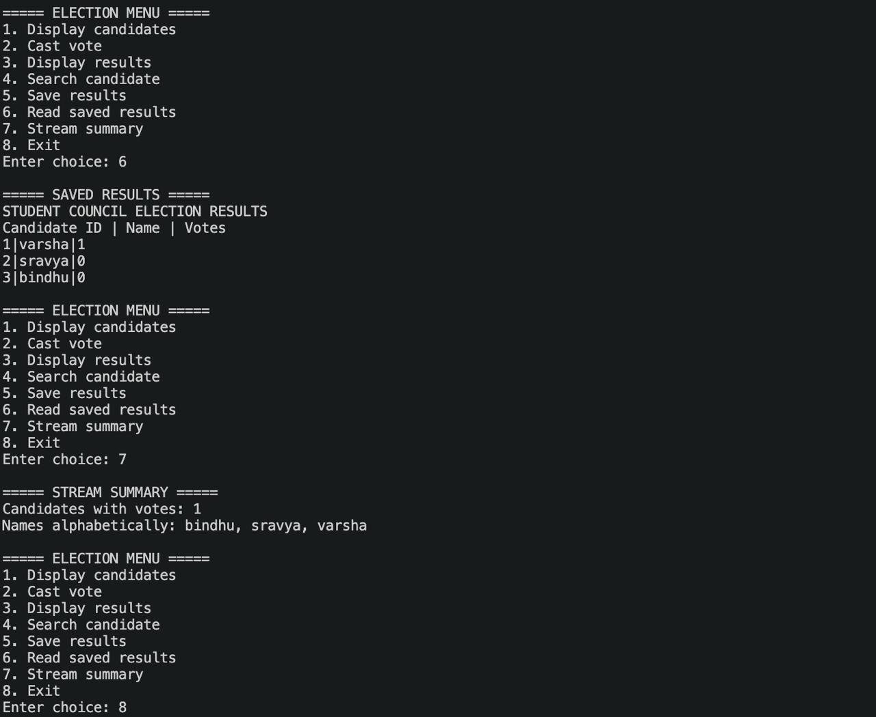

CONCLUSION
The Student-Council Election Tally System successfully demonstrates how Java programming can be used to solve a real-world problem in an organized and efficient manner. The project begins with problem-solving techniques and basic programming concepts in CO1, applies selection statements and loops in CO2, and develops modular functionality using methods, recursion, and arrays in CO3. It further incorporates object-oriented programming and exception handling in CO4, string manipulation, searching, sorting, and file handling in CO5, and collections, lambda expressions, and streams in CO6.
By combining these concepts, the application provides features for candidate management, vote recording, result calculation, winner identification, candidate searching, and saving election results. The project strengthens practical knowledge of Java programming while demonstrating the importance of modularity, data organization, and error handling in software development. In the future, the system could be enhanced with a graphical user interface, database integration, secure voter authentication, and additional reporting features to make election management more comprehensive.

